Eunice Lim

Web 335

Assignment 3.3- NodeBookCo

4/1/2021

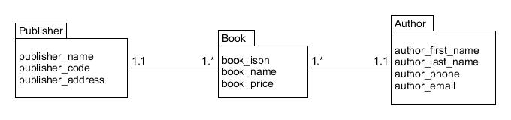ORD:

NoSQL document diagram:

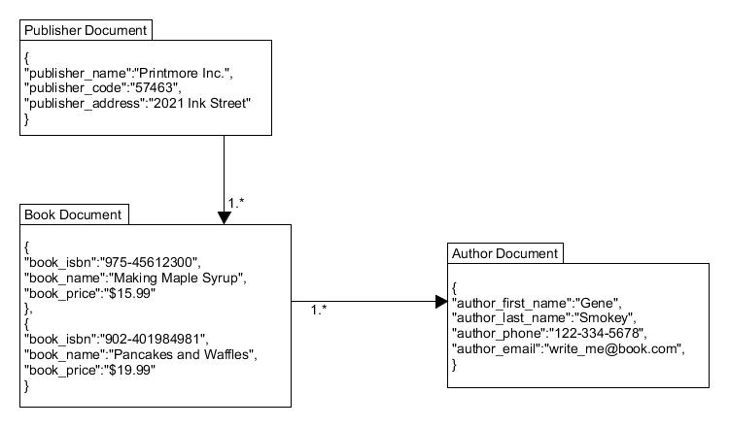Business Rules:

A PUBLISHER can have many BOOKs

Many BOOKS can have one AUTHOR

One AUTHOR can have many BOOKS

